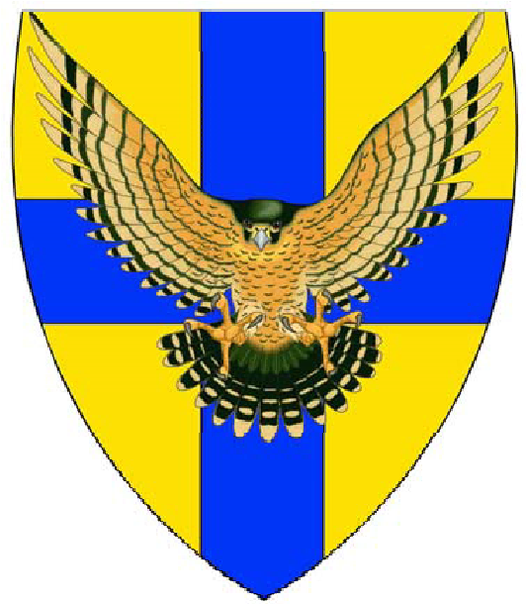
Noak Hill Archers
Summer Beginners Course
3/10/17 August 2019

Perhaps you have never shot a bow before, or maybe you've had a go at archery at an activity day or while on holiday. Either way we welcome anybody who wants to try archery with a view to possibly taking up the sport and joining a club. Our instructors will teach you the correct technique & ensure you know how to shoot safely.

We now have places on our summer beginners’ course, all welcome all you need to bring is a willingness to learn and have fun.
Courses start on each day at 10.00 and last for 3 hours each day.

Cost is £40 per person for the whole weekend, this includes all the equipment you will need and plenty of tea and coffee.

If interested please e-mail noakhillcoach@outlook.com
Or check out our website at https://www.noak-hill-archers.info/

